Kingdom of Saudi Arabia

Ministry of Education

Al-Baha University

Faculty of Computing and Information

Department of Systems and Networks

المملكة العربية السعودية

وزارة التعليم

جامعة الباحة

كلية الحاسبات والمعلومات

قسم النظم والشبكات

المملكة العربية السعودية

وزارة التعليم

جامعة الباحة

كلية علوم الحاسب وتقنية المعلومات

لجنة مشاريع التخرج

**Final Year Project Report**

Senior Project for CIS 1

CRN: ………

Submitted in partial satisfaction of the requirements for the

Degree of Bachelor’s in Computer Information Systems

*Entitled:*

**………………………..**

**Computer Information Systems**

**Al-Baha University**

*Undertaken by:*

Aseel Ateeq 444017590

Arwa Abdullah 444015565

Haneen Abdullah 444017158

Norah Mohammed 444018426

Raghad Ahmed 444017135

*Supervised by:*

Mohammed Idris

Month 2025

**FINAL APPROVAL**

Certified that we have read this project report submitted by (Students’ names), in our judgment it fulfils sufficient standard to warrant its acceptance.

***Committee:***

* Examiner 1 ____________________________

(Examiner Name)

Designation

* Examiner 2 ____________________________

(Examiner Name)

Designation

* Supervisor ____________________________

(Supervisor Name)

Designation

# Project Brief

Project Name /* A */

Department Name /* Dpt. Name */

Undertaken By /* Student 1 Full Name */

/* Student 1 Full Name */

/* Student 1 Full Name */

/* Student 1 Full Name */

Supervised By /* Supervisor Name */

/* Designation */

/* Department Name */

/* University Name */

Started on /* Start Date */

Completed on /* End Date */

Computer Used hp

Source Language /* Language Name &Version */

Operating System /* Name of OS */

Tools Used /* Names of Tools */

# Acknowledgements

We would like to acknowledge this work to ....

# Dedication

*We would also like to dedicate this project to*

*………*

# Abstract

This project aims to develop a web-based platform for managing academic and professional recommendation letter requests between students and faculty members. The current process of requesting and writing recommendation letters is often disorganized, time-consuming, and inefficient, as it typically relies on informal communication and lacks a centralized system.

This leads to challenges such as unclear requirements, forgotten requests, and lower-quality recommendations due to limited information.

The proposed solution is to create an electronic platform that allows students to submit structured recommendation requests and provides faculty members with tools to manage and respond to these requests effectively.

The system will feature components such as customizable templates, smart forms that collect detailed student information, and a tracking mechanism to monitor the status of each request. It will also include user authentication to ensure secure interactions between students and professors.

The target users of this project are university students seeking academic or professional recommendations and faculty members responsible for writing them.

The expected contributions of this project include improving the quality and professionalism of recommendation letters, reducing the workload on faculty, and ensuring a more organized and transparent communication process. Overall, this project aims to enhance the recommendation experience and support students in achieving their academic and career goals.

**Keywords:** (terms, acronyms, and abbreviations you used during the report)

# Table of Contents

Project Brief 1

Acknowledgements 2

Dedication 3

Abstract 4

Table of Contents 5

List of Figures 7

List of Tables 0

Chapter I INTRODUCTION 1

1.1. Background and Motivation 1

1.2. Problem Definition 2

1.3. Aim and Objectives 3

1.4. Proposed Solution to Problem 3

1.5. Scope and Domain 4

1.6. Limitations (if any) 4

1.7. Project Management Plan 4

1.8. Outline 5

Chapter 2 LITERATURE REVIEW 6

3.1. Introduction 6

3.2. Similar Studies 6

3.3. Summary 6

Chapter 3 Feasibility Study 9

4.1. Introduction 9

4.2. Operational Feasibility 9

4.3. Technical Feasibility 10

4.4. Economic Feasibility 11

4.5. Schedule Feasibility 11

Chapter 4 SYSTEM ANALYSIS 12

5.1. Software Development Methodology Used 12

5.2. Stakeholders Identification 12

5.3. Requirements Gathering and Analyzing 12

5.4. System Analysis 12

5.5. Summary 19

Chapter 5 System Design 20

6.1. Detailed System Design and component descriptions 20

6.2. Database Design 20

6.3. User Interface Design 20

6.4. Summary 20

Chapter 6 Implementation 21

6.1. Introduction **Error! Bookmark not defined.**

6.2. Details ........ 21

6.3. Summary 21

Chapter 7 Testing 22

7.1. Introduction 22

7.2. Details ........ **Error! Bookmark not defined.**

7.3. Summary **Error! Bookmark not defined.**

Chapter 8 CONCLUSION Error! Bookmark not defined.

8.1. Introduction **Error! Bookmark not defined.**

8.2. Future Work **Error! Bookmark not defined.**

List of References 23

Appendix A 24

# List of Figures

....

....

# List of Tables

……

# Chapter I INTRODUCTION

## Background and Motivation

Background:

In recent years, applying for academic and professional programs has increasingly required the preparation of a set of documents that reflect a student’s qualifications and competencies — among the most important of these is the letter of recommendation.

These letters serve as a vital tool used by receiving entities — such as universities, employers, or scholarship committees — to form an objective impression of the applicant through an academic figure who has direct knowledge of the individual’s abilities, behaviors, and skills.

Their importance grows in competitive environments, where they can serve as a decisive factor in accepting one applicant over another, especially when written professionally and issued by a trusted source.

Despite the evolution of education and its shift from traditional to digital models, many educational institutions still rely on outdated methods when it comes to recommendation systems.

Typically, the student must personally approach the faculty member or send an email requesting a recommendation.

These requests are often disorganized and lack the necessary detail, forcing the professor to ask for additional information or to write a generic and non-specific letter — thereby reducing its value.

Moreover, with the increasing number of students and the diversity of their academic and professional goals, the burden on faculty members has become greater than ever. They are required to manage a large volume of requests in a short period while maintaining high standards of writing and content.

This highlights the urgent need for a smart and reliable digital platform that can reorganize the entire process — from submitting the request to delivering the recommendation — while ensuring privacy, quality, and ease of use.

Motivation:

Letters of recommendation are essential for graduate students when applying for jobs, graduate programs, or scholarships. However, the process of requesting and managing recommendations is often haphazard and disorganized, consuming significant time and effort for both students and professors.

On the one hand, professors receive a large number of recommendation requests via various channels, such as email or live chat, making it difficult to track and manage them effectively. This confusion can lead to delayed responses or forgotten requests, which negatively impacts students.

Conversely, students face challenges in requesting recommendations in a professional manner, as they lack a clear mechanism for tracking the status of their requests and ensuring they are submitted on time. This can lead to missed academic and professional opportunities due to delays or failure to receive high-quality recommendations.

The Athar Graduate Website aims to address these issues by providing an integrated e-system that facilitates students’ submission of recommendation requests in an organized and professional manner, while also allowing professors to easily manage and track requests through a unified platform. By digitizing the process, the system addresses time concerns by significantly reducing delays and unnecessary back-and-forth communication.

Moreover, the platform contributes to enhancing sustainability by minimizing the use of paper and traditional manual processes, aligning with modern trends in environmentally responsible digital transformation. The system also prioritizes authentication and data integrity, ensuring that all requests and recommendations are securely submitted and verified within a trusted environment.

This solution will simplify the process and reduce administrative burdens, ensuring that recommendations are sent efficiently and on time, while improving the quality of communication between students and professors, and promoting a more reliable and future-ready academic environment.

## Problem Definition

Many students face recurring challenges when attempting to obtain a recommendation letter from one of their professors, especially during the stages of applying for academic or professional opportunities. These difficulties often begin with the student’s inability to identify the most suitable professor to write the letter, particularly when there has been limited interaction or academic connection between them. This lack of familiarity can lead to a weak or generic recommendation.

The absence of a clear system or dedicated platform for requesting recommendation letters further adds to the confusion. In many cases, students are unsure about what exactly is required—whether the recommendation should be academic or professional—and are unclear about the proper format or the type of information they should provide. As a result, miscommunication may occur, and the process may be delayed or compromised.

Another common issue is the student’s tendency to procrastinate. Many students wait until the last minute to submit their request, which places significant time pressure on the professor. This can negatively affect the quality of the letter and, in some cases, cause the student to miss important application deadlines.

In some instances, the recommendations received are vague or lack depth due to the student’s failure to provide sufficient background information, such as achievements, skills, or academic performance. When a professor does not know the student well, the recommendation may come across as impersonal, which can reduce its impact.

Psychological barriers also play a role. Many students hesitate to ask for recommendations due to fear of rejection or concern about burdening the professor. This hesitation can prevent them from seeking a valuable opportunity that could significantly support their academic or career path.

Many students also struggle due to the lack of a centralized source that brings together all the necessary information related to recommendation letters. There is no clear platform that provides guidelines, templates, or examples to help students understand how to request a letter, what content should be included, or even the best ways to communicate with professors. This gap in resources leads to confusion, leaving some students unsure of where to start, which results in incomplete or low-quality requests. A platform offering centralized and well-structured information would help simplify the process and save time and effort for both students and professors.

Additionally, accessing professors is not always easy or convenient for students, especially in large universities or programs with a high number of students. Office hours are often limited, and some professors do not provide opportunities for communication outside of lectures. This challenge reduces the chance to build strong academic relationships, which are key to receiving impactful recommendation letters. Moreover, some students rely solely on email, which can make communication less effective and lower the likelihood of receiving timely responses or adequate support.

## Aim and Objectives

### Aim :

To provide an organized and efficient platform that facilitates the process of requesting letters of recommendation for graduate students, while helping professors manage and track requests smoothly.

### Objectives:

1. Enable students to request letters of recommendation in a professional and organized manner.
2. Provide a simplified system for professors to manage requests and easily approve or reject them.
3. Reduce the time and effort required by both parties by limiting random and unorganized communication.
4. Ensure the confidentiality and security of letters of recommendation.
5. Improve students' chances of receiving strong and reliable recommendations when applying for jobs, graduate studies, or scholarships.
6. Enable students to easily and clearly track the status of their applications.
7. Promote professional communication between students and professors through a formal

## Proposed Solution to Problem

The proposed solution for this project is to develop an intelligent and integrated online platform (Athar Graduate) that simplifies and organizes the process of requesting and writing academic and professional recommendation letters between students and faculty members. The platform is designed to address the common challenges faced by both parties by automating the workflow and providing a streamlined, efficient environment that ensures the quality and timeliness of recommendations.

Through the platform, graduating students will be able to submit official recommendation requests by filling out a detailed form that includes their academic background, resume, goals, and information about the institution or company they are applying to. This request is then sent directly to the selected professor in an organized and professional manner, with tracking features available to monitor its status.

On the professor’s side, a personalized dashboard will allow them to easily view incoming requests. The platform will offer smart tools such as customizable templates to help them write tailored recommendations efficiently without starting from scratch. Additionally, it will include access to previous student records to support writing accurate and personalized letters.

The system will also include a reminder system, which sends automated notifications to professors regarding pending requests and approaching deadlines, ensuring that no recommendation is delayed or overlooked. Furthermore, it will allow recommendations to be sent directly to the intended recipients in the required format and language. All documents will be securely stored in a database, making it easy for both students and professors to access them in the future.

By implementing this solution, the recommendation process becomes more professional, organized, and less time-consuming. It reduces the burden on faculty members and significantly improves the quality and effectiveness of the recommendations students receive—ultimately enhancing their chances of being accepted into academic programs or professional opportunities..

## Scope and Domain

Scope:

The project includes the design and development of an electronic platform that enables graduating students or those about to graduate to request academic or professional recommendations from faculty members in a professional and organized manner.

The platform also provides smart tools to facilitate the efficient and quick preparation of recommendations by professors, along with the ability to save and track the status of these recommendations.

Domain:

The proposed solution is to design a digital platform that allows students to submit complete recommendation requests and enables faculty members to easily prepare recommendations using smart templates. This accelerates the process and enhances its quality for both sides.

## Limitations (if any)

…………

## Project Management Plan

(Including deliverables and schedule – Gantt Chart)

## Outline

(An overview of your report structure)

# Chapter 2 LITERATURE REVIEW

## Introduction

This chapter aims to present a comprehensive review of the literature and previous studies related to digital systems and platforms designed to streamline the management of recommendation letters. It highlights the most prominent models and technologies that have been utilized in this context, analyzing their effectiveness, strengths, and weaknesses, as well as identifying gaps that have yet to be addressed. This review serves as a crucial step in understanding the broader context in which the “Athar Graduate” project operates, helping to adopt best practices and avoid the pitfalls encountered in earlier initiatives.

Furthermore, the literature review provides insights into current market trends and reveals the level of user acceptance for such systems, along with their impact on the quality of educational outcomes. It also emphasizes the growing role of intelligent tools, integration with cloud services, and user experience (UX)-driven design in enhancing the overall effectiveness of digital solutions in the academic domain.

## Similar Studies

**King Khalid University:**

Recommendation letters at King Khalid University are considered an important tool for students applying for academic or career opportunities after graduation. These letters are usually issued by faculty members who have taught the student during their academic journey, and they highlight academic and personal qualities such as diligence, skills, commitment, and the ability to learn and work in a team.

* **Advantages**
* Strong University Reputation:
  + - King Khalid University is well-known in Saudi Arabia, and its name adds credibility to the recommendation letters issued by its faculty.
* Diversity of Faculties and Instructors:
  + - Due to the university’s large size and variety of colleges, students have a higher chance of finding qualified instructors who can write strong recommendation letters.
* Experience in Writing Recommendations:
  + - Some departments are accustomed to writing letters for students applying to graduate programs or scholarships, which means they often have experience in professional academic writing.
* Electronic Support Systems:
  + - The university provides online portals that help facilitate the submission and follow-up of academic requests, including systems dedicated to recommendations and academic communication.

**Disadvantages**

* Generic and Repetitive Letters:
  + In some cases, recommendation letters are reused for multiple students without personalization, which diminishes their authenticity and impact.
* Lack of Specificity:
  + Many recommendation letters are written in a general format and are not tailored to a specific purpose (such as a job or academic program), which reduces their effectiveness with institutions that prefer more targeted content.
* Delays in Response or Submission:
  + Faculty members may sometimes delay in preparing or sending the recommendation, causing stress for students, especially when deadlines are approaching.

**King Faisal University:**

Recommendation letters at King Faisal University are an important tool that students rely on when applying for academic opportunities such as graduate studies or scholarships, as well as certain job opportunities. These letters are typically issued by faculty members who have taught the student during their academic journey and focus on highlighting academic performance, research skills, discipline, and analytical abilities

.

* **Advantages**
* Good Academic Reputation:
  + - King Faisal University holds a respected reputation within the Kingdom, which gives its recommendation letters a good level of acceptance among many institutions.
* Faculty with Strong Research Backgrounds:
  + - Some faculty members are involved in research and publish in academic journals, which enhances the professionalism and impact of the recommendation letters they provide.
* Possibility of Receiving Recommendations from Project or Internship Supervisors:
* Students can obtain recommendations from their graduation project or internship supervisors, which are often more specific and detailed.
* Ease of Academic Communication through Electronic Systems:
  + - The university provides official channels for communication between students and faculty, such as the university email and the Banner system, making it easier to request recommendations professionally.

**Disadvantages:**

* Lack of Customization:

Some recommendation letters are written in a general format and not tailored to a specific purpose (such as a job or graduate program), which reduces their effectiveness.

* Lack of Time or Delays:

Some faculty members delay in submitting recommendation letters due to their busy schedules, which puts pressure on students, especially close to deadlines.

* Signature-Only Approach:

In some cases, faculty members ask students to write the recommendation themselves, and the professor only signs it, which reduces the credibility of the letter.

* Lack of Follow-Up After the Request:

In certain cases, the recommendation request is not followed up on, forcing the student to continuously remind the professor, which may lead to delays in receiving the letter.

Summary

Through an analysis of the existing literature and previous studies, it becomes evident that several attempts have been made to develop technological solutions aimed at simplifying the process of requesting and writing recommendation letters. Some of these systems focused solely on digitizing recommendation forms, while others introduced more integrated solutions that included request management, status tracking, and facilitated communication between students and faculty members. However, not all of these initiatives proved to be fully effective or practical. Several suffered from poor user experience, a lack of intelligent features, or limited integration with existing academic infrastructures.

This review highlights a significant gap in the market—the absence of a unified, comprehensive platform that addresses both academic and technical needs while offering a seamless experience for both users. There is a growing demand for a system that supports customization, provides editable recommendation templates, and ensures high standards of data security and privacy.

In light of these findings, the “Athar Graduate” project emerges as a promising solution that builds upon the shortcomings of previous systems. It leverages intelligent design principles and technical integration to offer a robust, user-centered platform. Therefore, this literature review serves as a foundational step in developing a new, well-informed system based on scientific and practical insights

# Chapter 3 Feasibility Study

## Introduction

Before initiating the development of any system or digital solution, it is essential to conduct a feasibility study to assess whether the project is viable from multiple perspectives. A feasibility study helps determine if the proposed solution can be successfully implemented in terms of technical capabilities, economic resources, operational practicality, and legal or ethical considerations. It serves as a foundation for informed decision-making and ensures that efforts are directed toward a solution that is realistic, cost-effective, and beneficial to all stakeholders involved.

In the case of the “Athar Graduate” platform, the feasibility study aims to evaluate whether building an intelligent digital system for managing recommendation letters is a practical and advantageous approach to resolving the challenges currently faced by students and faculty. This chapter will present an analysis of the project’s technical, operational, and economic feasibility.

It will explore whether the required technology and infrastructure are available, whether the target users are capable of adopting and using the system effectively, and whether the platform provides a justifiable return on investment based on the time, effort, and resources involved.

Through this evaluation, the feasibility study seeks to support the development team in validating the potential of the Athar Graduate platform to achieve its intended goals and to ensure that it aligns with institutional priorities and user needs.

## Operational Feasibility

Operational feasibility evaluates how effectively the proposed system can function within the existing environment and how well it addresses the identified challenges and meets the needs of end users. This dimension of the feasibility study focuses on the practicality of adopting and utilizing the system by the stakeholders involved — primarily students, faculty members, and academic institutions.

The current process of requesting and writing recommendation letters is largely manual, relying on informal communication channels such as emails, direct messages, or in-person interactions. This leads to inefficiencies such as lack of organization, delays in response, missed deadlines, and even lost requests. Furthermore, faculty members often face a significant workload, and without a standardized system, the quality and personalization of the recommendation letters may suffer.

The proposed Athar Graduate platform directly addresses these issues by providing a digital solution that streamlines the entire recommendation process. By offering structured request forms, smart templates, automated reminders, and a centralized dashboard for both students and professors, the platform reduces confusion, increases efficiency, and ensures a higher level of organization. The system also enables better communication, faster response times, and a clear method for tracking request statuses — all of which contribute to a smoother experience for both parties.

In addition, the platform supports seamless integration into the daily academic operations with minimal disruption, as it is designed to be user-friendly, accessible, and adaptable to the needs of different educational institutions. This operational readiness enhances the likelihood of successful adoption and continued use.

Therefore, from an operational perspective, the Athar Graduate system is highly feasible. It effectively solves the key pain points identified in the requirements analysis phase, aligns with institutional workflows, and adds value to both students and faculty by improving the quality, speed, and reliability of recommendation processes.

## Technical Feasibility

The purpose of this section is to evaluate whether the proposed technology and solutions are practical and feasible within the current technical standards. We will assess the tools and technologies to be used for project implementation and whether the required technical expertise is available.

|  |  |
| --- | --- |
| Element | Details |
| Programming Languages | HTML, CSS, JavaScript, PHP – These are the primary technologies used for frontend and backend development. |
| Development Environment | Visual Studio Code will be used as the primary development tool, a popular code editor supporting all the aforementioned technologies |
| Database Management | MySQL will be used for secure and organized data storage. It is a flexible relational database system suitable for small to medium-sized applications. |
| Hosting Servers | The site will be deployed on cloud platforms like AWS or Google Cloud to provide flexible scaling, reliability, and meet security requirements. |
| Operating Systems | Windows and Linux will be used for development and testing purposes, as they are among the most commonly used operating systems |
| Security Tools | SSL/TLS for encryption and JWT (JSON Web Tokens) for session management and data security. Role-Based Access Control (RBAC) mechanisms will be implemented to manage permissions. |
| External System Integrations | Integration with email systems for notifications and electronic signatures for document verification. |

## Economic Feasibility

The economic feasibility of the project identifies the expected costs. We found that the technologies used for developing the website (such as HTML, CSS, JavaScript, and PHP) are free and open-source. In addition, the development tools we plan to use, such as Visual Studio Code, are also free, which helps reduce the overall project cost

**Table 3.2:** Economic Feasibility – Software Requirements Costs

|  |  |
| --- | --- |
| item | cost |
| HTML, PHP, CSS, JavaScript: Free | Free |
| Visual Studio Code | Free |
| MySQL | Free |

**Table 3.3**: Economic Feasibility – Hardware Requirements Cost

|  |  |
| --- | --- |
| item | cost |
| Laptop | 5000 SAR |
| Internet Subscription (1 Year) | 1800 SAR |
| Total Estimated Cost | 6300 SAR |

## Schedule Feasibility

< Are the project deadlines reasonable? Are specified deadlines mandatory or desirable?>

# Chapter 4 SYSTEM ANALYSIS

## Software Development Methodology

Waterfall, agile .... etc.

## Stakeholders Identification

**Graduating students or those nearing graduation** are the primary beneficiaries of the project. They rely on the platform to request recommendations in an organized and professional manner. Their role involves submitting requests and providing academic and personal information that enables faculty members to write accurate and effective letters.

**Faculty members (professors)** are the providers of recommendation letters. Their importance lies in their academic experience and interaction with students, which allows them to write personalized and meaningful recommendations. The platform helps simplify the process by offering tools such as ready-to-use templates and quick access to student information.

**Universities and academic** **institutions** are potential partners in the project, whether through official adoption or integration with their internal systems. Their role is essential in supporting the platform’s use within the educational environment and contributing to enhancing the quality of recommendations issued by the institution.

Finally, the technical support and cybersecurity team plays a vital role in maintaining the system’s security and data protection, ensuring that the platform operates reliably and securely in line with modern technical standards.

## Requirements Gathering and Analyzing

Functional Requirements

* 1. User Registration and Login
* The system must support account creation and login for both students and faculty members.
  1. Create Recommendation Request
* Students should be able to fill out a form including their academic information, resume, and the target institution.
  1. Send Request to Faculty Member
* The request should be sent directly to the selected professor through the platform.
  1. Student Dashboard
* Allows students to track the status of their requests, edit or cancel them if needed.
  1. Faculty Dashboard
* Enables faculty members to review, accept, or reject requests, and generate recommendations using smart templates.
  1. Predefined Recommendation Templates
* The platform should provide editable templates to facilitate the writing process for faculty members.
  1. Notification System
* Sends alerts to both students and faculty about request status, updates, or submission deadlines.
  1. Recommendation Submission
* Allows the recommendation to be sent electronically to the target institution or downloaded in the appropriate format.
  1. Recommendation Archiving
* Stores all submitted recommendations in a secure database for future access by either the student or faculty member.

Non-Functional Requirements

1. Security

* Protect user information and recommendation letters from unauthorized access.

1. Usability

* Provide a simple and user-friendly interface suitable for all types of users (students and faculty members).

1. Performance

* Ensure fast loading times and high responsiveness when using the platform.

1. Reliability

* Guarantee stable system performance with minimal downtime or technical errors.

1. Scalability

* Allow the platform to scale in the future to support a larger number of users or multiple universities.

1. Compatibility

* Ensure the platform works across various devices and browsers (mobile, desktop, tablet).

System Analysis

Use the different UML diagrams in this section such as:

Use Case Diagram

**Use Case Description: Log in**

|  |  |
| --- | --- |
| ID | UC01 |
| Title | Log in |
| Description | This case allows the user (graduating student, doctor, or admin) to log into the system using their previously registered credentials to access the services designated for them. |
| Primary Actor | User (graduating student, doctor, admin) |
| Preconditions | The user must have a previously registered account in the system. |
| Postconditions | The user is directed to the appropriate main interface based on their role after successful login verification.. |
| Main Scenario | 1.The user opens the system.  2.The user selects “Login.”  3. The user enters the username and password.  4.The system verifies the accuracy of the credentials.  5.The user is logged in and directed to their main page. |
| Alternative Scenarios / Extensions | -If the user does not have an account, they are directed to the “Register” use case. -If the login credentials are incorrect, the system displays an error message and prompts the user to try again. |
| Frequency of Use | It is used every time the user needs to log into the system. |
| Status | Under Development |
| Owner | Ather Graduate development Tea |
| Priority | Very High |

**Use Case Description: New order**

|  |  |
| --- | --- |
| ID | UC02 |
| Title | New order |
| Description | This use case allows the student to create a new recommendation request from a professor for a specific course or academic topic. |
| Primary Actor | Graduating Student |
| Preconditions | -The student must be logged into the system.  -The student must be connected to the internet |
| Postconditions | The request data is updated if modified, or removed from the system if canceled. |
| Main Scenario | 1. Student logs into the system. 2. Navigates to 'My Requests' page. 3. Selects the request to be modified or canceled. 4. If modifying: updates the required data and clicks 'Save'. 5. If canceling: clicks 'Cancel Request' and confirms the action. 6. A success confirmation message is displayed. |
| Alternative Scenarios / Extensions | - If the student has no existing requests, a message indicating this is displayed. - If incorrect data is entered during modification, an error message appears and a retry is requested. |
| Frequency of Use | Available whenever the student needs to modify or cancel their request. |
| Status | Analysis and Design Phase |
| Owner | Ather Graduate development Tea |
| Priority | Very High |

**Use Case Description: Track request**

|  |  |
| --- | --- |
| ID | UC03 |
| Title | Track request |
| Description | This use case enables the student to track the-status of a previously submitted recommendation request, providing visibility into whether the request has been approved, is under review, or has been rejected |
| Primary Actor | Graduating student |
| Preconditions | -The student must be logged into the system.  -The student must be connected to the internet |
| Postconditions | - The recommendation request is sent to the professor. - The student is notified that the request has been successfully submitted. - The professor is notified of the new request. |
| Main Scenario | 1. The student logs into the system.  2. The student selects “New order”.  3. The student selects the course.  4. The student selects the professor.  5. The student fills out the request form.  6. The student clicks “Submit Request”.  7. A notification is sent to the professor. |
| Alternative Scenarios / Extensions | - If the student has no registered courses with the selected professor, the system displays a message indicating that the request cannot be submitted.  - If there is a connection or network issue, the system displays an error message and asks the student to try again.  - If the professor is unavailable or not registered in the system, they will not appear in the selection list |
| Frequency of Use | Each time the student needs to submit a recommendation request |
| Status | Analysis and Design Phase |
| Owner | Ather Graduate Development Team |
| Priority | Very High |

**Use Case Description: View request**

|  |  |
| --- | --- |
| ID | UC04 |
| Title | View request |
| Description | This use case allows the student to modify previously entered recommendation request data in the system or cancel the request entirely when needed |
| Primary Actor | Graduating student |
| Preconditions | The Graduating student must have a previously submitted recommendation request in the system. |
| Postconditions | The request data is updated if modified, or removed from the system if canceled. |
| Main Scenario | 1. Student logs into the system.  2. Navigates to 'My Requests' page.  3. Selects the request to be modified or canceled.  4. If modifying: updates the required data and clicks 'Save'.  5. If canceling: clicks 'Cancel Request' and confirms the action.  6. A success confirmation message is displayed. |
| Alternative Scenarios / Extensions | - If the student has no existing requests, a message indicating this is displayed.  - If incorrect data is entered during modification, an error message appears and a retry is requested. |
| Frequency of Use | Available whenever the student needs to modify or cancel their request. |
| Status | Analysis and Design Phase |
| Owner | Ather Graduate Development Team |
| Priority | Very High |

**Use Case Description: Write Recommendation**

|  |  |
| --- | --- |
| ID | UC09 |
| Title | Write Recommendation |
| Description | This use case allows the professor to write a personalized recommendation letter in response to an approved request from a student for a specific academic purpose |
| Primary Actor | Professor |
| Preconditions | • The professor must be logged into the system.  • The recommendation request must be approved.  • The professor must have access to the student’s academic details. |
| Postconditions | The request data is updated if modified, or removed from the system if canceled. |
| Main Scenario | 1. The professor logs into the system.  2. The professor navigates to the “Approved Requests” section.  3. The professor selects a specific student’s request.  4. The system displays a recommendation template or an empty editor.  5. The professor writes the recommendation letter content.  6. The professor saves the recommendation.  7. The system confirms that the recommendation has been saved successfully. |
| Alternative Scenarios / Extensions | - If the professor exits without saving, the system prompts to save or discard the draft.  - If the student’s academic data is incomplete, the system displays a warning and may prevent submission.  - If the professor tries to access a non-approved request, the system shows an access restriction message. |
| Frequency of Use | Each time a professor writes a recommendation for an approved student request. |
| Status | Analysis and Design Phase |
| Owner | Ather Graduate Development Team |
| Priority | Very High |

Context Diagram (or Basic class diagram) to describe the context of your project).

System Sequence Diagrams (SSD)

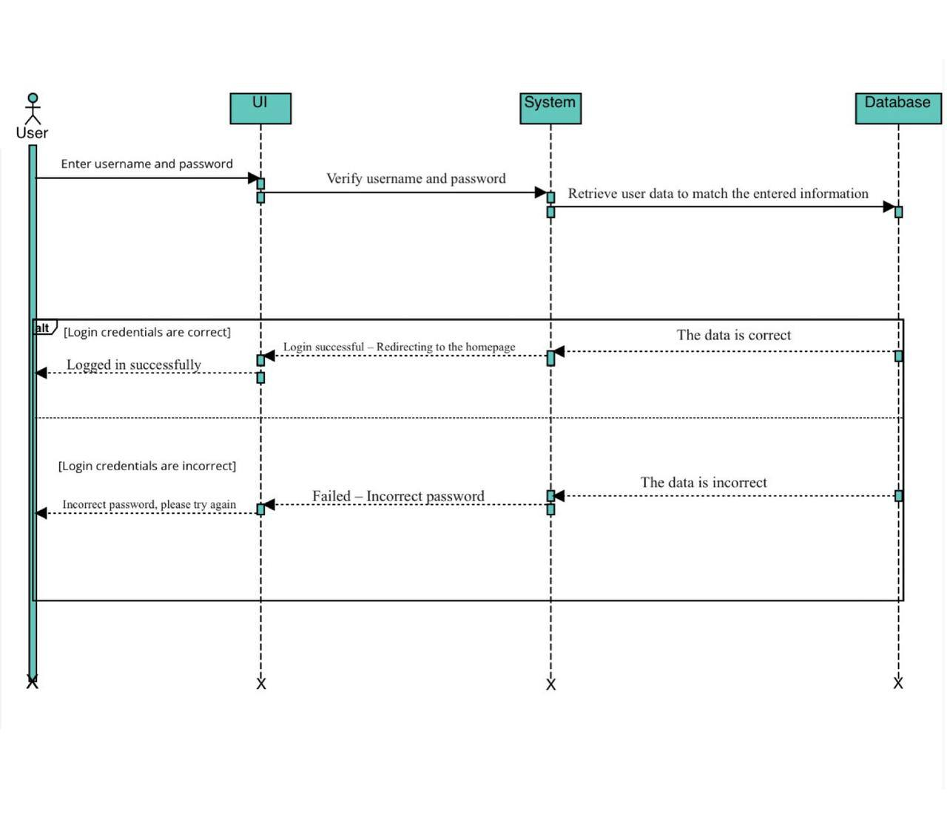Figm2

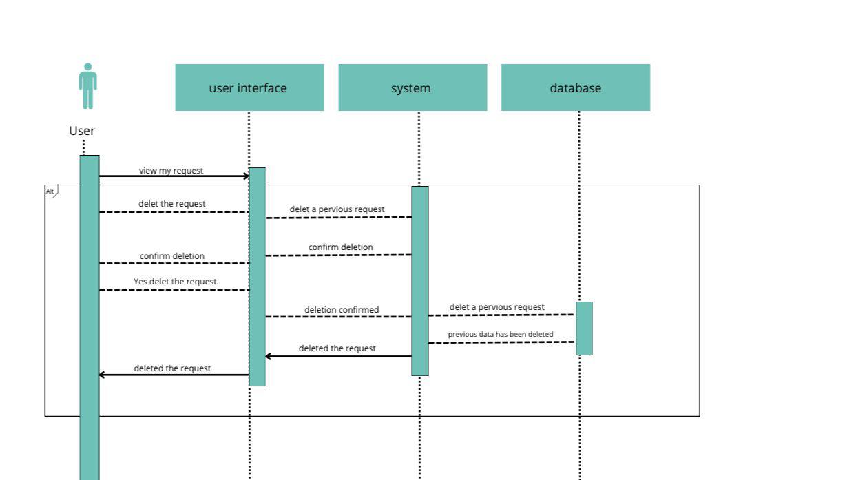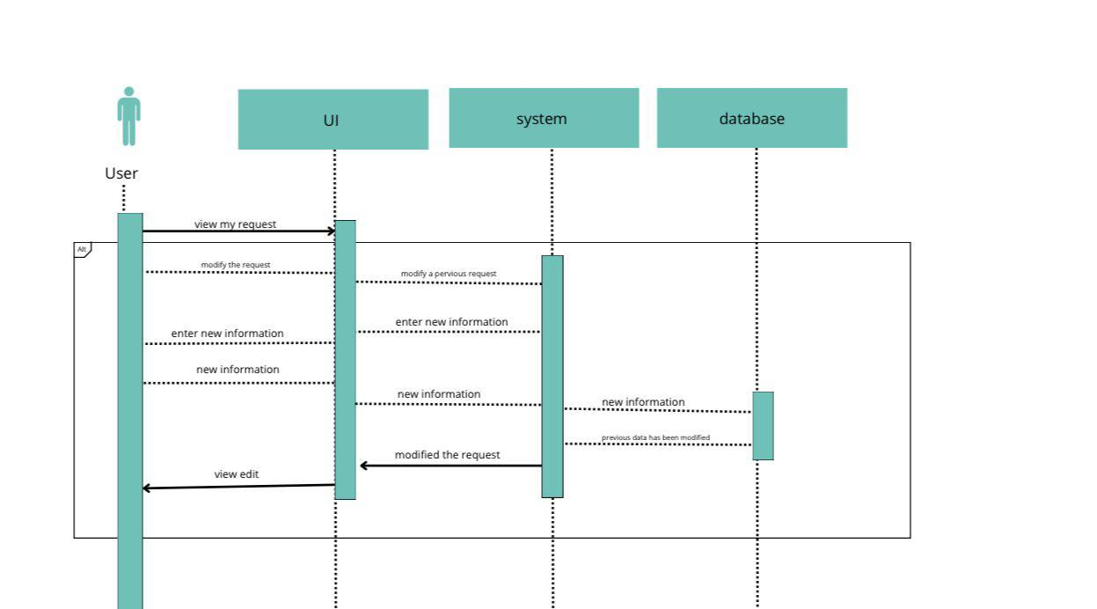

## Summary

………

# Chapter 5 System Design

## Detailed System Design and component descriptions

Components Description (use one of the architecture design patterns or UML component diagram to illustrate the components of your proposed system)

Sequence Diagrams (SQD) to describe the detailed interaction between objects in each use case.

Activity Diagram to describe the different activities and related actions of your system.

## Database Design

Use UML class diagram with more details describing classes, their attributes and methods, and the detailed relationships between them.

You can also use ERD diagram to indicate the primary and secondary keys for each entity. This will help you later to implement your database.

Show how your database is built using SQL oracle.

## User Interface Design

Use any tools to describe user interfaces for your system and show the logic of moving from one interface to another.

## Summary

………

# Chapter 6 Implementation and Testing plan

## Implementation Plan

Give a proposal of how you will transform your models and designs to actual implementation (code): what tools you will use, what programming languages you will use, how you will do.

## Testing Plan

Give a proposal of how you will test your system: You can describe how you will conduct unit, integration, and system testing. Also, if you will use specific tools, describe them here.

## Summary

………

# Chapter 7 Conclusion

## Introduction

Summary of what you did and what you learned. Also, provide the limitations of your work if you have any.

## Future Work

………

# List of References

<You should follow a suitable format (APA, MLA, etc.) for writing the list of references.>

…….

# Appendix A

<Here you can put any extra materials such as figures, or illustrations of the results, samples of surveys, interviews.>

………………..